**Assignment**

**Learner Details**

* **Name: Nikhil k**
* **Enrollment Number: SU625MR004**
* **Batch / Class: June 2025 MERN**
* **Assignment: Nodejs**
* **Date of Submission: 12/08/2025**

**Problem Solving Activity 1.1**

**1. Program Statement**

Create a Node.js module using CommonJS and ES6 that performs basic math operations:

addition, subtraction, multiplication, division, and modulus division..

**2. Algorithm**

Step 1: Define functions ,implement add(a,b), sub(a,b), mul(a,b), div(a,b), and moddiv(a,b).

Step 2: Validate inputs ,ensure both arguments are numbers and handle invalid input.

Step 3: Handle division-by-zero, make div return an error value/message or throw when b ===0.

Step 4: Prepare exports , expose the functions using module.exports (CommonJS) or export

(ES6).

Step 5: Import in caller, bring functions in with require('./Math') (CommonJS) or import ... from

'./Math.js' (ESM).

Step 6: Call functions — invoke each operation with sample values and collect results.

Step 7: Output results, console.log () or return the results to the caller for verification.

Step 8: Configure runtime ,ensure package.json "type" and file extensions (.js/.cjs/.mjs) match

your chosen module system.

Step 9: Test edge cases, run the script, and verify behavior for normal and edge inputs (e.g., zero,

negative, non-number).

**3. Pseudocode**

3. Pseudocode

START

DEFINE FUNCTION add(a, b):

RETURN a + b

DEFINE FUNCTION sub(a, b):

RETURN a - b

DEFINE FUNCTION mul(a, b):

RETURN a * b

DEFINE FUNCTION div(a, b):

IF b IS 0:

PRINT "Error: Division by zero"

RETURN null

ELSE:

RETURN a / b

DEFINE FUNCTION moddiv(a, b):

RETURN a % b

EXPORT all functions as module.exports

END

**4. Program Code**

const add = (a,b) => {

  return (

    a+b

  )

}

const sub = (a,b) => {

  return (

    a-b

  )

}

const div = (a,b) => {

  return (

    a/b

  )

}

const mul = (a,b) => {

  return (

    a*b

  )

}

// module.exports = {add,sub};

export default {add,sub,div,mul};

**6. Screenshots of Output**

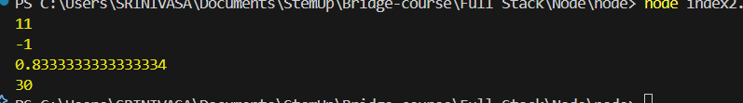

**7. Observation / Reflection**

The require() error occurred due to ES module mode in package.json, highlighting the need to

understand CommonJS vs ES Modules for smooth Node.js development.